### List of Use Case

#### <Guest>Overview Use Case

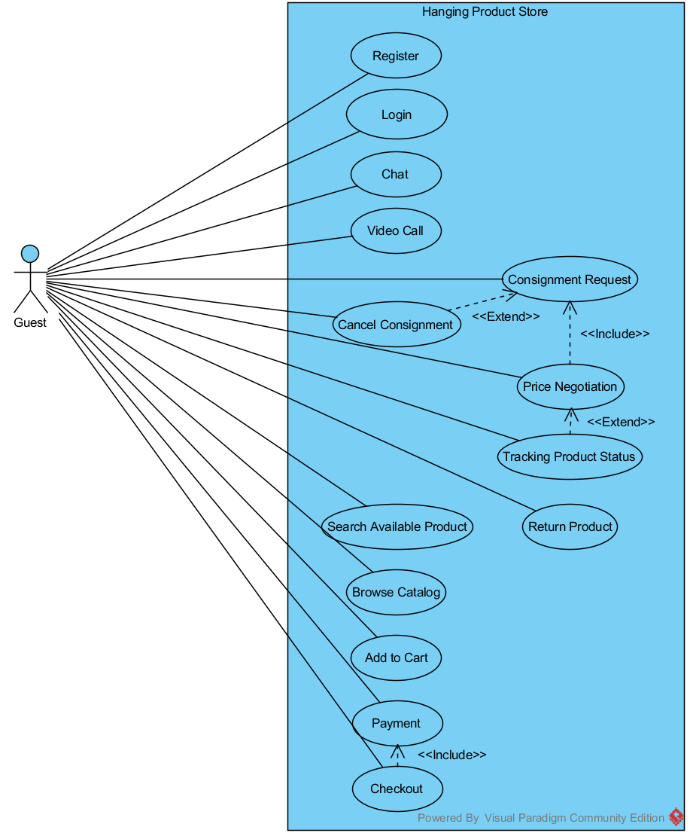

Figure 3: <Guest> Overview Use Case

##### <Guest> Price Negotiation

Use Case Diagram

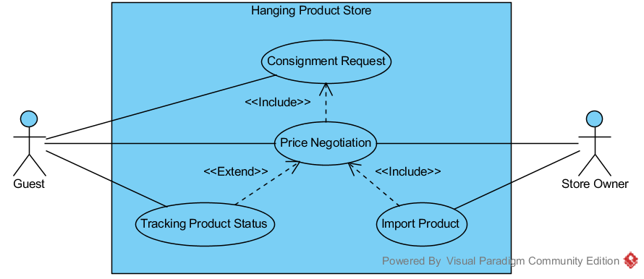

Figure 4: <Guest> Price Negotiation

Use Case Specification

|  |  |  |  |
| --- | --- | --- | --- |
| **USE CASE – UC_01** | | | |
| **Use Case No.** | UC_01 | Use Case Version | 1.0 |
| **Use Case Name** | Price Negotiation | | |
| **Author** | PhucTQ | | |
| **Date** | May 23, 2015 | Priority | High |
| **Actor**:   * Guest/Customer with role Consignor * Store Owner with role Consignee   **Summary**:   * This use-case use to come to an agreement on consign price between Consignor and Consignee.   **Goal**:   * An agreement on consign price is reached.   **Triggers**:   * Consignment Request use-case is finished.   **Preconditions**:   * Product is in state Submitted/Web Verified.   **Post Conditions**:   * **Success**: Product is in state Accepted. * **Fail**: N/A   **Main Success Scenario**:   |  |  |  |  | | --- | --- | --- | --- | | Step | Consignor Action | Consignee Action | System Response | |  | Finish submit product. |  |  | |  |  |  | Notify chosen consignees. | |  |  | Click “View” button in notifying pop-up. |  | |  |  |  | Redirect to Request Detail page. | |  |  | Check product information.  Click “Accept” button. [Alternative 1] |  | |  |  |  | Notify Consignor. | |  | Go to Sell page.  Click “View” button. |  |  | |  |  |  | Open Negotiation dialog box | |  | Click “Accept” button. [Alternative 2], [Alternative 2b] |  |  | |  |  |  | Change Product status to Accepted. |   **Alternative Scenario**: Alternative 1   |  |  |  |  | | --- | --- | --- | --- | | No | Consignor Action | Consignee Action | System Response | |  |  | On Request Detail page:  Check product information.  Click “Negotiate” button. |  | |  |  |  | Open Negotiation dialog box.. | |  | Enter new price.  Click “Submit” button. |  |  | |  |  |  | Notify Consignor. |   **Alternative Scenario**: Alternative 2   |  |  |  |  | | --- | --- | --- | --- | | No | Consignor Action | Consignee Action | System Response | |  | Enter new price.  Click “Submit” button. |  |  | |  |  |  | Notify Consignee. |   **Alternative Scenario**: Alternative 2b   |  |  |  |  | | --- | --- | --- | --- | | No | Consignor Action | Consignee Action | System Response | |  | Click “Refuse” button. |  |  | |  |  |  | Notify Consignee. |   **Exceptions**:   |  |  |  | | --- | --- | --- | | No | Actor Action | System Response | |  |  |  |   **Relationships**:   * Included Use-case:   + Consignment Request * Extended Use-case:   + N/A * Including Use-case:   + Import Product * Extending Use-cases:   + Tracking Product Status   **Business Rules**:   * One Consignor can negotiate with many Consignees and vice versa. * Once actors refuse to negotiate (either Consignor or Consignee can do), they cannot negotiate again. * Consignor makes final decision. * Consignor can refuse accept requests make by consignees. * Consignor cannot accept refuse requests make by consignees. * For each product, Consignor can only accept one Consignee. | | | |